**Running cellranger for sn data**

First of all, let’s walkthrough the files

* Cellranger_run_loop.sh is the bash script that will take sample names one-by-one from the samples.csv file and run cellranger count on them. These sample names are the same as the prefixes found in corresponding fastq filenames.
* Example, for the sn test data analysed before, the fastq files for the two samples Sample_12 and Sample_FF were as below. So the sample names I used in the script were also Sample_12 and Sample_FF.
  + Sample_12_S11_R1_001.fastq.gz
  + Sample_12_S11_R2_001.fastq.gz
  + Sample_FF_S12_R1_001.fastq.gz
  + Sample_FF_S12_R2_001.fastq.gz

Before running the script, you need to download the latest version of cellranger from the link below since on the st-server we only have cellranger 3 installed which is quite old version.

I have installed cellranger 7.0.1 which was latest at the time I ran sn data but then 10x has cellranger 7.1 now since 7th December 2022. Either of these will work fine with the script.

* *https://support.10xgenomics.com/single-cell-vdj/software/pipelines/latest/installation?src=social&lss=wechat&cnm=soc-we-ra_g-program&cid=7011P000000oOU6*

Once cellranger is installed you need to change the line of code in the script where I source the cellranger software as below:

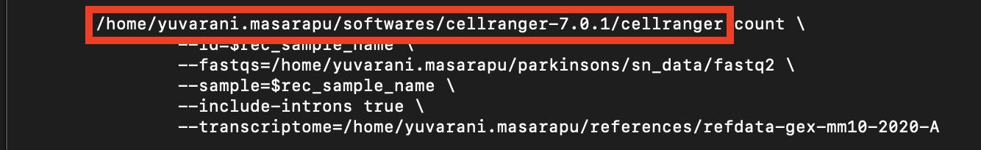

The path highlighted here needs to be one where you installed cellranger. In my case, I created a folder named *softwares* and then followed installation instructions from 10x for cellranger linked above. You cannot use the same path as it’s private for me on the server and other users don’t have access to each other’s private repositories.

Then make sure you place all the sequencing files under one folder, in my case it’s *fastq2* and change the path highlighted below.

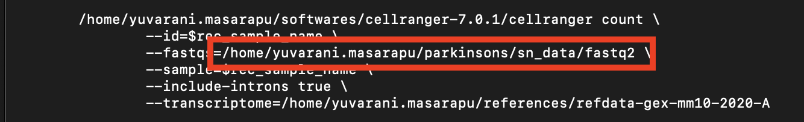

Same goes for the path below which is the latest transcriptome reference for mouse data. The one on the server commonly available for all users under */home/fastdisk/10x/refdata-gex-mm10-2020-A*can be used here.

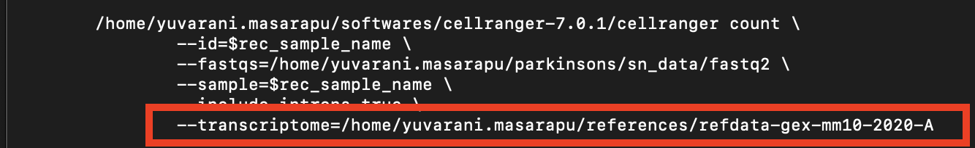

Finally, depending on how many samples you have, you might need to estimate and change the first 6-7 lines of the bash script stating the maximum time to run the script, script name, your email etc to monitor script progress.

Now your script is customized and ready!

Now open the *samples.csv* file and replace the **Sample_FF and Sample_12** with the sample names (as in the sequencing fastq files) you want. Please make sure the sample names in the fastq filenames and the ones added here match. And the sample names should follow each other as a column.

Then, go to the folder where you want your cellranger outputs and place this cellranger_run_loop.sh script and also the samples.csv file. Now run the below command:

* *sbatch cellranger_run_loop.sh samples.csv*

This will submit your bash script job and you can monitor its progress via *squeue* command in the server.